

Surname and name

Warsaw Medical University
Clinic / Department (full name)

TITLE (of the exam)
studies: FIELD (of study), year (of studies)

Version 0 (number of the version)

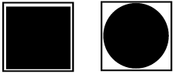
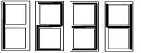
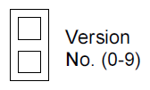
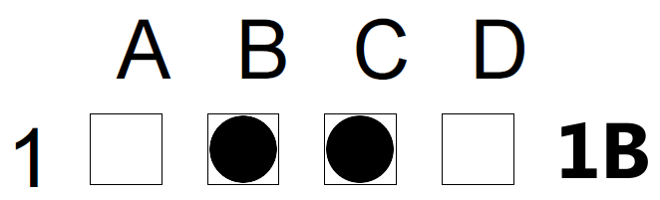
Instruction

The answers’ sheet must be signed in the "Signature" box and the test booklet readably signed with your surname and name;
On the answers’ sheet: fill in the number of the version of the test booklet using “block writing” in the field as shown beside:

The answers must be marked only on the answers’ sheet, please note that answers marked in the test booklet will not be taken into account;
The answer should be properly marked by filling in the interior
of the chosen square (A, B, C, D or E) situated on left to the
question numbers, within these frames, as shown beside:
Don’t write outside of the square lines;
For each question there is only one correct answer;
The answers must be marked on the answers’ sheet clearly with the black pencil or with black or dark blue pen;
In case you have made a mistake, leave the incorrect answer (don’t cross it out) and mark the another one in the appropriate square. In such case of double marking – also write the correct answer on the right side
of the appropriate column, as shown beside:
Don’t fold the answers’ sheet. Don’t make other marks than described below on the answers’ sheet. Don’t write or scribe around the black squares situated in the corners of the readable area.
GOOD LUCK!

Academic year 20……/20……

